JAVASCRIPT LAB ASSIGNMENT
Name:Pragati mahajan
Roll No:2424273
Course: B.Sc. IT
Semester: 5th Semester
Subject: JavaScript

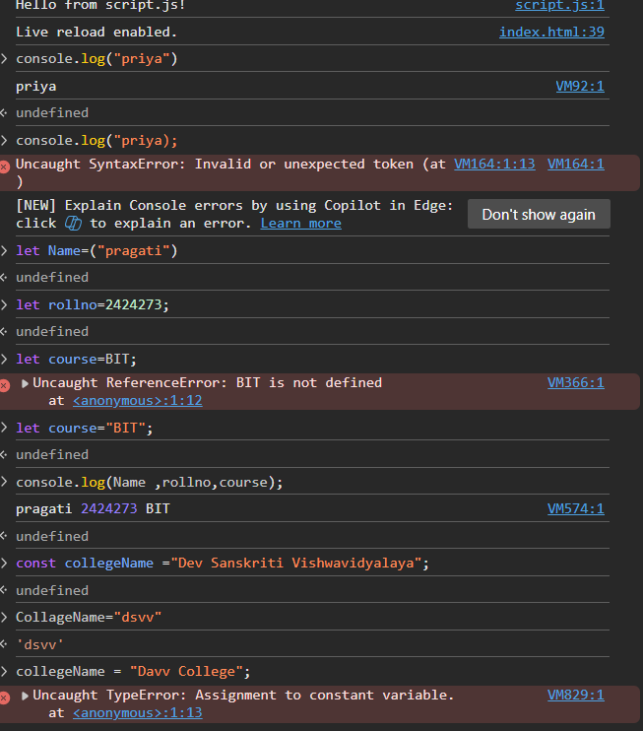
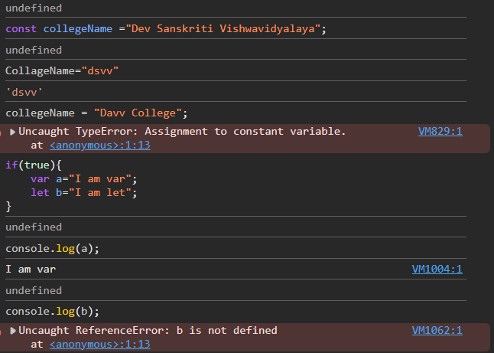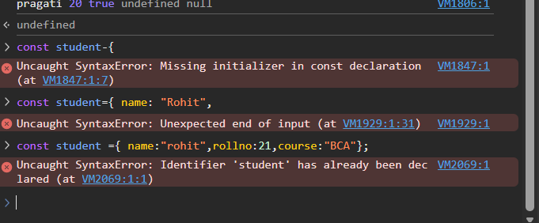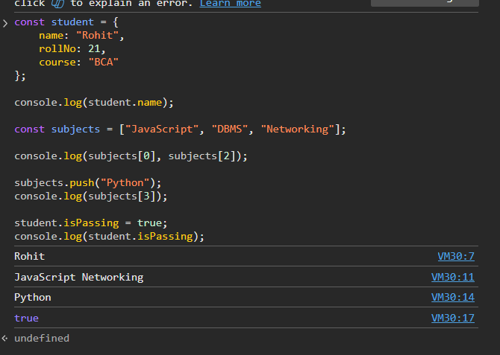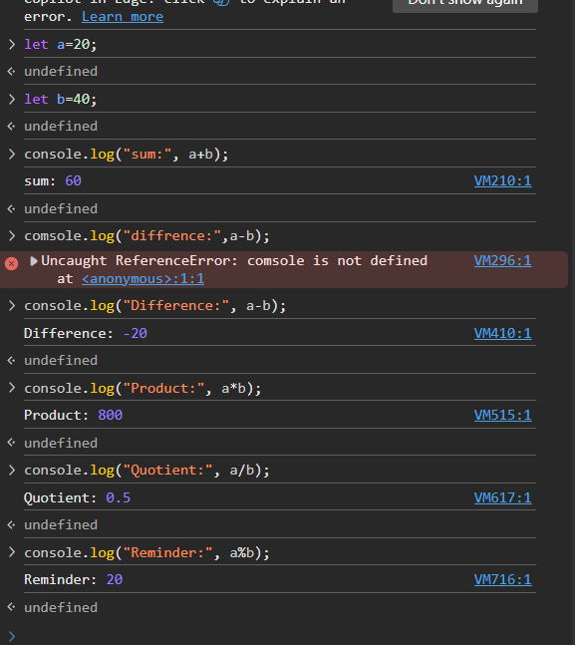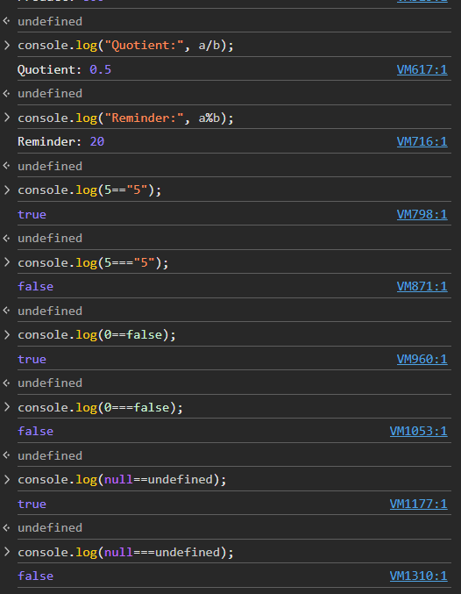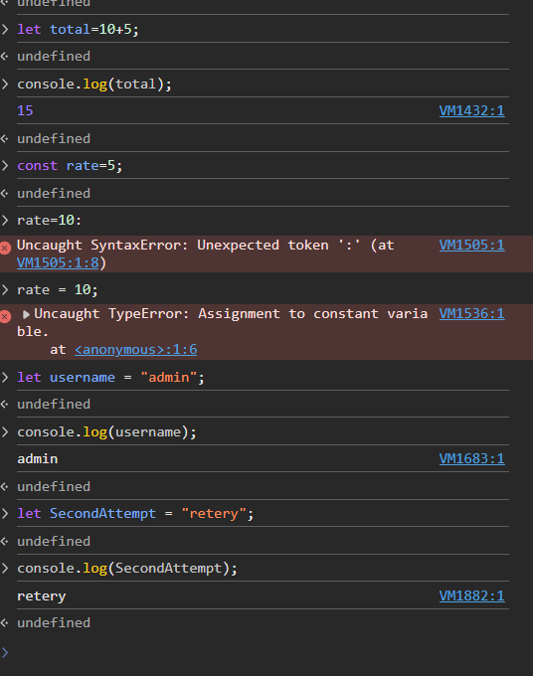
The most confusing part of today’s lab was understanding the difference between == and === and the different JavaScript errors during debugging. Practicing the examples in the console and checking the output helped me understand how type conversion, variable declarations, and operators work.

